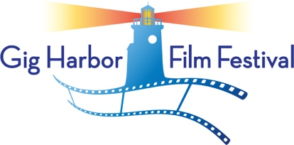
2020 72 Hour Film Competition
FILM CERTIFICATION

I ______________________________________________, Team Leader for _____________________________________________________, a team participating in the Gig Harbor 72 Hour Film Competition, hereby certify that all creative work on the film__________________________________________________________________, including all writing, shooting and editing occurred during the Official 72 Hour Time Period beginning Thursday March 12, 2020 at 6:00 PM local time and ending on Sunday, March 15, 2020 by 6:00 PM local time.
Signature ______________________________________________________________
Printed Name _________________________________________________________________
Date ____________________________

If Signatory is under 18:
I represent and warrant that I am the parent or guardian of the minor whose name appears above, that I have read and approve of the foregoing certification, and consent to its execution by my child/ward.

Signature of Parent/Guardian:

______________________________________________________

Name (please print): _____________________________________

Date: ____________________

